Statement of the Problem **(Revised)**

This study aims to determine the effectiveness of ultra violet lights in disinfecting using an automatic disinfection box.

Specifically, the study sought to find the answers to the following questions:

1. What is the significant difference between ultraviolet-based disinfectant and alcohol-based disinfectant in terms of their effectiveness? **(t test)**

2. What is the significant effect of ultraviolet intensity to be use in terms of its effectiveness? **(One sample t test)**

3. What is the significant difference among the different duration in terms of its effectiveness? **(anova)**

1. 10 sec
2. 20 sec
3. 30 sec

4. How does the automatic disinfection box be described in terms of: **(descriptive only, weighted mean only of result)**

a) Satisfaction

b) value for money

**Satisfaction**

1. On a scale of 1 to 5, how satisfied were you with using the device?
2. Very dissatisfied.
3. Somewhat dissatisfied.
4. Neither satisfied nor dissatisfied.
5. Somewhat satisfied.
6. Very satisfied.

**Low cost**

1. On a scale of 1 to 5, do you think this device is good value for money?
2. I do not think this device is good value for money at all.
3. I think this device is slightly good value for money.
4. I think this device is moderately good value for money.
5. I think this device is very good value for money.
6. I think this device is extremely good value for money.

**Protocol**

1. Prepare your agar plates.

2. Subject all the agar plated in UVC radiation.

3. Follow the following treatments and controls:

Negative control: Empty agar plate

Positive: Agar plate with S. aureus exposed to UVC (260-265 nm)

Treatment 1: Agar plate with S. aureus exposed to 10 seconds UVC

Treatment 2: Agar plate with S. aureus exposed to 20 seconds UVC

Treatment 3: Agar plate with S. aureus exposed in 30 seconds.

Plating Technique to Be Used: SPREAD PLATE

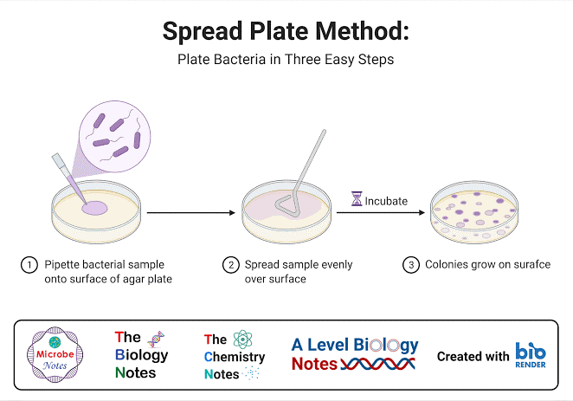

Replication: 3 petri dish per treatment.

References:

Rijal N. (June 2022), “Spread Plate Technique: Principle, Procedure, Results”, “microbeonline.com/spread-plate-technique/”